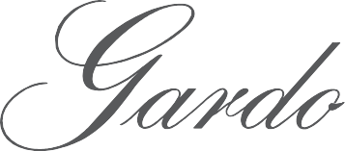

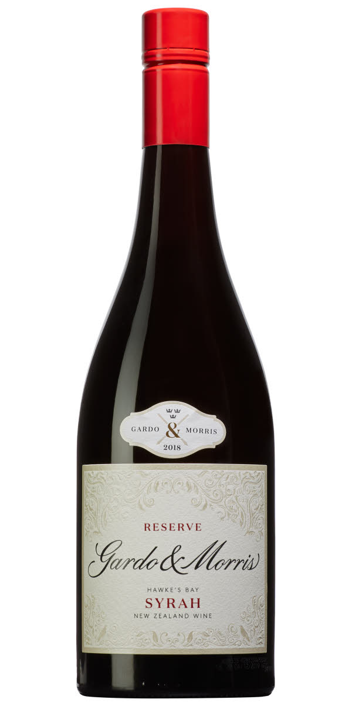

2019 Reserve Hawkes Bay Syrah
Ripe blackberries and red fruits combine with dark floral notes, smokey game, dried herbs, bay leaf and cracked pepper. It displays excellent depth with rich mouth-filling texture and power. Enjoy over the next decade or more.

– VITICULTURE AND WINE MAKING NOTES –
Our Syrah is handpicked from 2 vineyards in the Gimblett Gravels area of Hawkes Bay. The vineyards all have a shallow silt soil with very deep gravel beds beaneath . Low yields of around 3-4 ton / acre and a dry summer created perfect ripening conditions, March and April were dry and warm, and the low yielding crop ripened to optimum maturity, the berries were very small and concentrated this year giving extra concentration to the wine. 2020 produced some of the best Syrah we have every seen.
The grapes are very gently de-stemmed and crushed into small open top fermenters, after one week cold maceration natural yeast fermentation took place with regular hand plunging and pumpovers. After 3-4 weeks on skins the wine was gently run off by gravity and the skins were gently pressed. The wine then underwent maturation in 225L French barriques in about 30% of which were new.
Full malolactic fermentation in barrique has softened the acidity and added complexity. The wine is aged in barrique for approx 12 months, then after a light egg white fining it was bottled unfiltered.

– FOOD MATCHING SUGGESTIONS –
Best to be served around 16°C-18C accompanied with grilled steak, lamb and venison.

– THE PRODUCER –
Gardo & Morris is a small family-run boutique New Zealand Winery. Our aim is to create exceptional single vineyard wines from New Zealand’s finest winegrowing regions. These wines are made to complement food and reflect flavours of the vineyard site and grape variety. We believe that by working with small vineyard areas we are able to pick the very best fruit and with gentle treatment in the winery turn this into unique handcrafted wines. Benjamin Morris studied his Master of Applied Science (Oenology) at Lincoln University in New Zealand where he specialised in research on producing organic wines without the addition of preservatives. “Creating our wines with minimal vineyard sprays and additives is very important to us as it helps us produce pure clean wines and has the added benefit of sustaining a healthy environment”.

Vintage 2019
Region Hawkes Bay
Country New Zealand
Grape(s) Syrah
Alcohol 13.0%
Maturation Up to 12 months in French
barriques (20% new)

Gardo & Morris AB - Igelbodavägen 21, 133 38 Saltsjöbaden, Sweden - Ben Morris +46 (0) 702 600 332 info@gardomorriswines.se - www.gardomorris.com

